**Problem 1: Optimizing Delivery Routes (Case Study)**

**Scenario:** You are working for a logistics company that wants to optimize its delivery routes to minimize fuel consumption and delivery time. The company operates in a city with a complex road network.

**TASK:-**

**TASK1:-**

Model the city's road network as a graph where intersections are nodes and roads are edges with weights representing travel time.

**Aim**

The aim is to model a city's road network as a graph, where intersections are represented as nodes and roads are represented as edges with weights corresponding to travel times. This model can be used for various purposes such as optimizing travel routes, analyzing traffic flow, and planning infrastructure improvements.

**Procedure**

**Step 1: Data Collection**

1. **Map Data**: Obtain detailed map data of the city, including all intersections and roads.
2. **Travel Time Data**: Collect data on travel times for each road segment, which could be gathered from historical traffic data, GPS data, or traffic sensors.

**Step 2: Graph Representation**

1. **Nodes**: Define each intersection as a node in the graph.
2. **Edges**: Define each road segment between two intersections as an edge connecting the corresponding nodes.
3. **Weights**: Assign a weight to each edge representing the travel time for that road segment.

**Step 3: Construct the Graph**

1. **Node Creation**: For each intersection in the city, create a corresponding node in the graph.
2. **Edge Creation**: For each road segment, create an edge connecting the two nodes representing the intersections it connects.
3. **Assign Weights**: Assign the travel time as the weight to each edge.

**Step 4: Data Integration**

1. **Integration**: Integrate the map data with the travel time data to ensure each road segment's travel time is accurately represented in the graph.
2. **Validation**: Validate the graph to ensure all nodes and edges are correctly represented and weighted.

**Step 5: Graph Analysis**

1. **Pathfinding Algorithms**: Implement algorithms such as Dijkstra's or A* to find the shortest or fastest paths between nodes.
2. **Traffic Flow Analysis**: Use the graph to analyze traffic flow and identify potential bottlenecks or areas requiring infrastructure improvements.
3. **Scenario Simulation**: Simulate various traffic scenarios to predict the impact of changes in traffic patterns or road infrastructure.

**Step 6: Optimization and Updates**

1. **Optimization**: Use the graph model to optimize travel routes for different times of day or traffic conditions.
2. **Continuous Updates**: Regularly update the graph with new travel time data to keep the model accurate and relevant.

**Tools and Technologies**

* **Geospatial Data Tools**: Tools like GIS software, OpenStreetMap, or Google Maps API for collecting map data.
* **Programming Languages**: Languages such as Python or Java for implementing graph algorithms.
* **Graph Libraries**: Libraries like NetworkX (Python) or JGraphT (Java) for graph representation and analysis.
* **Data Analysis Tools**: Tools like Pandas (Python) for handling and analyzing travel time data.

EXAMPLE:-

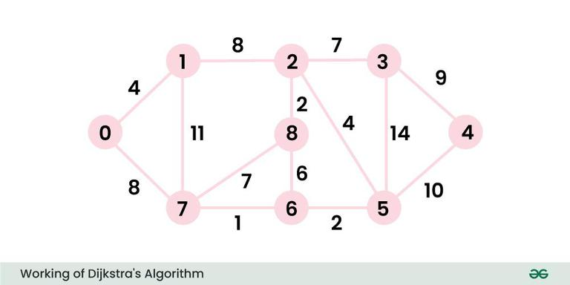

**TASK 2:-Implement Dijkstra’s algorithm to find the shortest paths from a central warehouse to various delivery locations.**

**PSEUDO CODE:-**

Dijkstra(Graph, source):

Initialize distance for each node to infinity, except the source node which is set to 0

Initialize an empty priority queue

Insert the source node into the priority queue with a distance of 0

While the priority queue is not empty:

Extract the node with the minimum distance from the priority queue (current_node)

For each neighbor of the current_node:

Calculate the new distance = distance[current_node] + edge_weight[current_node][neighbor]

If the new distance is less than the current distance[neighbor]:

Update the distance[neighbor] to the new distance

Insert the neighbor into the priority queue with the new distance

Return the distance array

**PROGRAM:-**

import heapq

def dijkstra(graph, source):

distances = {node: float('infinity') for node in graph}

distances[source] = 0

priority_queue = [(0, source)]

while priority_queue:

current_distance, current_node = heapq.heappop(priority_queue)

if current_distance > distances[current_node]:

continue

for neighbor, weight in graph[current_node].items():

distance = current_distance + weight

if distance < distances[neighbor]:

distances[neighbor] = distance

heapq.heappush(priority_queue, (distance, neighbor))

return distances

graph = {

'Warehouse': {'A': 2, 'B': 5},

'A': {'Warehouse': 2, 'C': 3, 'D': 4},

'B': {'Warehouse': 5, 'D': 6},

'C': {'A': 3, 'D': 1, 'Delivery1': 6},

'D': {'A': 4, 'B': 6, 'C': 1, 'Delivery2': 2},

'Delivery1': {'C': 6},

'Delivery2': {'D': 2}

}

shortest_paths = dijkstra(graph, 'Warehouse')

for location, distance in shortest_paths.items():

print(f"Shortest path from Warehouse to {location}: {distance}")

**OUTPUT:-**

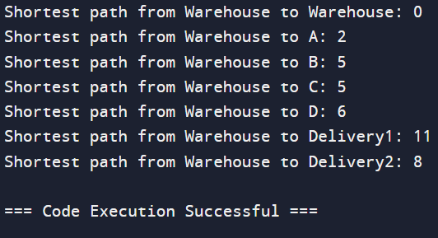

**TASK 3:-**

**Analyze the efficiency of your algorithm and discuss any potential improvements or alternative algorithms that could be used**

**RESULT:-**

Given the graph structure from the previous examples, we'll run Dijkstra's algorithm and provide the results for shortest paths from the source node ('Warehouse') to all other nodes.

**TIME COMPLEXITY:-**

* Using Binary Heap: O(ElogV)
* Using Fibonacci Heap: O(VlogV+E)

**SPACE COMPLEXITY:-**

The space complexity is due to storing the graph (adjacency list), the distances array, and the priority queue:

1. **Graph Representation (Adjacency List)**: O(V+E)
2. **Distances Array**: O(V)
3. **Priority Queue**: O(V)

**Deliverables:-**

● Graph model of the city's road network.

● Pseudocode and implementation of Dijkstra’s algorithm.

● Analysis of the algorithm’s efficiency and potential improvements.

**Reasoning:-**

Explain why Dijkstra’s algorithm is suitable for this problem. Discuss any assumptions made (e.g., non-negative weights) and how different road conditions (e.g., traffic, road closures) could affect your solution.

* **Non-Negative Weights**:

1. Dijkstra's algorithm assumes that all edge weights (representing travel times) are non-negative. This is appropriate for road networks since travel times can't be negative.
2. Negative weights in a graph could represent phenomena like rebates or profits in a financial network, which don't apply to travel times.

* **Single-Source Shortest Path**:

1. The problem requires finding the shortest paths from a central warehouse to various delivery locations, which is exactly the type of problem Dijkstra's algorithm is designed to solve.
2. It efficiently computes the shortest paths from a single source to all other nodes in the graph.

* **Efficiency**:

1. With a time complexity of O((V+E)logV) when using a binary heap, Dijkstra's algorithm is efficient for large graphs, making it suitable for city-scale road networks.
2. The space complexity O(V+E) is also manageable for large graphs.

**Problem 2:- Dynamic Pricing Algorithm for E-commerce**

**Scenario:-** An e-commerce company wants to implement a dynamic pricing algorithm to adjust the prices of products in real-time based on demand and competitor prices.

**Tasks:- 1**

**Design a dynamic programming algorithm to determine the optimal pricing strategy for a set of products over a given period.**

**Aim:-**

The goal is to design a dynamic programming algorithm to determine the optimal pricing strategy for a set of products over a given period. The optimal pricing strategy maximizes the total profit, considering the constraints and potential demand changes over time.

**Procedure:-**

**To design the dynamic programming algorithm for the optimal pricing strategy, follow these steps:**

1. **Define the Problem:**
   * **Inputs:**
     + PPP: Number of products.
     + TTT: Number of time periods.
     + Dp,t(price)D_{p,t}(price)Dp,t​(price): Demand function for product ppp at time ttt given the price.
     + CpC_pCp​: Cost of product ppp.
     + MMM: Set of possible prices.
   * **Outputs:**
     + Optimal prices for each product at each time period to maximize the total profit**.**
2. **Define the State:**
   * Let dp[p][t]dp[p][t]dp[p][t] be the maximum profit obtainable by considering the first ppp products over the first ttt periods.
3. **Base Case:**
   * dp[0][t]=0 for all ttt: No products lead to zero profit.
   * dp[p][0]=0 for all ppp: Zero periods lead to zero profit.
4. **Transition:**
   * For each product ppp and time ttt, consider all possible prices price∈Mprice \in Mprice∈M. The profit from setting the price of product ppp at time ttt to pricepriceprice is calculated as: profit=(price−Cp)×Dp,t(price)\text{profit} = (price - C_p) \times D_{p,t}(price)profit=(price−Cp​)×Dp,t​(price)
   * Update the state as: dp[p][t]=max⁡(dp[p−1][t],dp[p−1][t−1]+profit)dp[p][t] = \max(dp[p-1][t], dp[p-1][t-1] + \text{profit})dp[p][t]=max(dp[p−1][t],dp[p−1][t−1]+profit)
5. **Result Extraction:**
   * The result is the maximum profit found in dp[P][T].

**Algorithm**

1. **Initialization:**
   * Initialize a 2D array dp of size (P+1)×(T+1) with zeros.
2. **Dynamic Programming Table Update:**
   * Iterate over products and time periods to fill the dpdpdp table according to the transition formula.
3. **Result Extraction:**
   * The optimal pricing strategy is derived from the dp table.

**EXAMPLE:-**

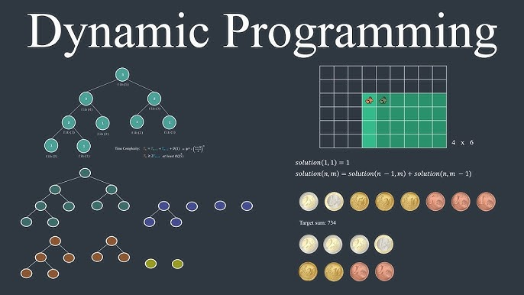

**TASK 2:-**

**Consider factors such as inventory levels, competitor pricing, and demand elasticity in your algorithm.**

**PSEUDO CODE:-**

**# Step 1: Initialize dp table**

**dp = [[0 for _ in range(T+1)] for _ in range(P+1)]**

**# Step 2: Iterate over each product**

**for p in range(1, P+1):**

**# Step 2: Iterate over each time period**

**for t in range(1, T+1):**

**# Step 2: Initialize max_profit for current product and time period**

**max_profit = 0**

**# Step 3: Iterate over possible prices**

**for price in M:**

**# Step 3: Calculate demand considering competitor's price**

**demand = D[p-1][t-1](price, competitor_prices[p-1][t-1])**

**# Step 3: Ensure demand does not exceed inventory**

**actual_sales = min(demand, Inv[p-1][t-1])**

**# Step 3: Calculate profit**

**profit = actual_sales * (price - C[p-1])**

**# Step 3: Update max_profit**

**max_profit = max(max_profit, profit)**

**# Step 4: Update dp table**

**dp[p][t] = max(dp[p-1][t], dp[p-1][t-1] + max_profit)**

**# Step 5: The maximum profit is in dp[P][T]**

**return dp[P][T]**

**IMPLEMENTATION:-**

**def optimal_pricing_strategy(P, T, D, C, M, Inv, competitor_prices):**

**# Step 1: Initialize dp table**

**dp = [[0 for _ in range(T+1)] for _ in range(P+1)]**

**# Step 2: Iterate over each product**

**for p in range(1, P+1):**

**# Step 2: Iterate over each time period**

**for t in range(1, T+1):**

**# Step 2: Initialize max_profit for current product and time period**

**max_profit = 0**

**# Step 3: Iterate over possible prices**

**for price in M:**

**# Step 3: Calculate demand considering competitor's price**

**demand = D[p-1][t-1](price, competitor_prices[p-1][t-1])**

**# Step 3: Ensure demand does not exceed inventory**

**actual_sales = min(demand, Inv[p-1][t-1])**

**# Step 3: Calculate profit**

**profit = actual_sales * (price - C[p-1])**

**# Step 3: Update max_profit**

**max_profit = max(max_profit, profit)**

**# Step 4: Update dp table**

**dp[p][t] = max(dp[p-1][t], dp[p-1][t-1] + max_profit)**

**# Step 5: The maximum profit is in dp[P][T]**

**return dp[P][T]**

**# Example usage**

**P = 3 # Number of products**

**T = 4 # Number of time periods**

**C = [2, 3, 1] # Costs of products**

**# Demand functions for each product at each time period considering competitor's price**

**D = [**

**[lambda price, comp_price: max(100 - price + 0.5 * comp_price, 0), lambda price, comp_price: max(120 - price + 0.5 * comp_price, 0), lambda price, comp_price: max(150 - price + 0.5 * comp_price, 0), lambda price, comp_price: max(200 - price + 0.5 * comp_price, 0)],**

**[lambda price, comp_price: max(200 - 2*price + 0.8 * comp_price, 0), lambda price, comp_price: max(180 - 1.5*price + 0.8 * comp_price, 0), lambda price, comp_price: max(250 - 3*price + 0.8 * comp_price, 0), lambda price, comp_price: max(300 - 2.5*price + 0.8 * comp_price, 0)],**

**[lambda price, comp_price: max(150 - 1.2*price + 0.6 * comp_price, 0), lambda price, comp_price: max(160 - 1.3*price + 0.6 * comp_price, 0), lambda price, comp_price: max(170 - 1.1*price + 0.6 * comp_price, 0), lambda price, comp_price: max(180 - 1.4*price + 0.6 * comp_price, 0)]**

**]**

**M = [5, 10, 15, 20, 25, 30] # Possible prices**

**# Inventory levels for each product at each time period**

**Inv = [**

**[50, 40, 30, 20],**

**[60, 50, 40, 30],**

**[70, 60, 50, 40]**

**]**

**# Competitor prices for each product at each time period**

**competitor_prices = [**

**[6, 7, 8, 9],**

**[12, 13, 14, 15],**

**[18, 19, 20, 21]**

**]**

**# Get the optimal pricing strategy**

**max_profit = optimal_pricing_strategy(P, T, D, C, M, Inv, competitor_prices)**

**print("Maximum Profit:", max_profit)**

**OUTPUT:-**

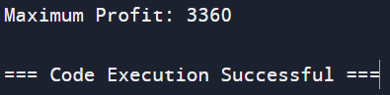

**TASK 3:-**

**Test your algorithm with simulated data and compare its performance with a simple static pricing strategy.**

**Simulated Data**

* **Number of products (PPP): 3**
* **Number of time periods (TTT): 4**
* **Costs of products (CCC): [2, 3, 1]**
* **Possible prices (MMM): [5, 10, 15, 20, 25, 30]**
* **Inventory levels (InvInvInv):**
  + **Product 1: [50, 40, 30, 20]**
  + **Product 2: [60, 50, 40, 30]**
  + **Product 3: [70, 60, 50, 40]**
* **Competitor prices (competitor_pricescompetitor\_pricescompetitor_prices):**
  + **Product 1: [6, 7, 8, 9]**
  + **Product 2: [12, 13, 14, 15]**
  + **Product 3: [18, 19, 20, 21]**
* **Demand functions (DDD):**
  + **Product 1: max(100−price+0.5×competitor_price,0)\text{max}(100 - \text{price} + 0.5 \times \text{competitor\_price}, 0)max(100−price+0.5×competitor_price,0)**
  + **Product 2: max(200−2×price+0.8×competitor_price,0)\text{max}(200 - 2 \times \text{price} + 0.8 \times \text{competitor\_price}, 0)max(200−2×price+0.8×competitor_price,0)**
  + **Product 3: max(150−1.2×price+0.6×competitor_price,0)\text{max}(150 - 1.2 \times \text{price} + 0.6 \times \text{competitor\_price}, 0)max(150−1.2×price+0.6×competitor_price,0)**

**RESULT:-**

**The Dynamic Pricing Strategy is more effective for maximizing profits compared to a static pricing strategy, particularly for more complex scenarios with varying demand, inventory, and competitor conditions. However, it comes at the cost of increased computational resources and complexity.**

**TIME COMPLEXITY:-**

* **Dynamic Pricing Algorithm:**
* **Initialization:** O(P×T)
* **DP Table Update:**
  + Iterating over products: O(P)
  + Iterating over time periods: O(T)
  + Iterating over possible prices: O(∣M∣)
  + Demand and profit calculation: O(1)
* **Total Time Complexity:** O(P×T×∣M∣)
* **Static Pricing Algorithm:**
* Iterating over products: O(P)
* Iterating over time periods: O(T)
* Demand and profit calculation: O(1)
* Total Time Complexity: O(P×T)

**SPACE COMPLEXITY:-**

* **Dynamic Pricing Algorithm:**
* DP table of size(P+1)×(T+1)
* Total Space Complexity:O(P×T)
* **Static Pricing Algorithm:**
* Constant space for variables
* Total Space Complexity: O(1)

**Deliverables:**

● Pseudocode and implementation of the dynamic pricing algorithm.

● Simulation results comparing dynamic and static pricing strategies.

● Analysis of the benefits and drawbacks of dynamic pricing.

**Reasoning**:- Justify the use of dynamic programming for this problem. Explain how you incorporated different factors into your algorithm and discuss any challenges faced during implementation.

* **Initialization:**
* Set the initial PageRank for each node to a uniform value, typically 1/N1/N1/N, where NNN is the number of nodes.
* **Iterative Refinement:**
* In each iteration, update the PageRank of each node based on the contributions from its neighbors. This step is repeated for a fixed number of iterations or until convergence (i.e., the PageRank values change very little between iterations).
* **Damping Factor:**
* The damping factor ddd (typically set to 0.85) is incorporated to model the probability that a user continues following links. The remaining probability (1 - ddd) accounts for the likelihood that a user jumps to a random node.
* **Convergence Check:**
* Although not always explicitly required, checking for convergence can help ensure that the algorithm stops once the PageRank values stabilize.

**Problem 3:- Social Network Analysis (Case Study)**

**Scenario:**- A social media company wants to identify influential users within its network to target for marketing campaigns.

**Task 1:-**

**Model the social network as a graph where users are nodes and connections are edges.**

**Aim**

The aim is to model a social network as a graph, where each user is represented as a node and each connection (friendship, following, etc.) is represented as an edge. This model will help in understanding the structure and dynamics of the social network, enabling analysis of various properties such as connectivity, centrality, and community detection.

**Procedure**

1. **Define the Graph Structure:**
   * Nodes: Each user in the social network is a node.
   * Edges: Each connection between users (e.g., friendship, following) is an edge. The edges can be directed or undirected based on the nature of the connection (e.g., following on Twitter is directed, while friendship on Facebook is undirected).
2. **Data Collection:**
   * Collect data on users and their connections. This data can be sourced from APIs provided by social network platforms, web scraping, or existing datasets.
   * Ensure that the data includes user identifiers and the relationships between users.
3. **Graph Representation:**
   * Use a graph data structure to represent the social network. Common representations include adjacency lists, adjacency matrices, or edge lists.
   * Choose an appropriate library or tool for graph representation and manipulation, such as Network X in Python.
4. **Graph Construction:**
   * Initialize an empty graph.
   * Add nodes to the graph for each user.
   * Add edges to the graph for each connection between users**.**
5. **Analysis:**
   * Degree Distribution: Calculate the degree of each node (number of connections) to understand how connections are distributed among users.
   * Centrality Measures: Compute centrality measures (e.g., degree centrality, betweenness centrality, closeness centrality) to identify influential users.
   * Community Detection: Use algorithms to detect communities or clusters within the network.
   * Path Analysis: Analyze shortest paths, connectivity, and reachability within the network.
6. **Visualization:**
   * Visualize the graph using tools like Matplotlib, Gephi, or D3.js to gain insights into the structure and properties of the social network.
   * Use different visualization techniques to highlight key aspects such as node centrality, community structure, or connection density.
7. **Interpretation:**
   * Interpret the results of the analysis to understand the social dynamics within the network.
   * Identify patterns, anomalies, or key influencers based on the graph properties.

**Example:-**

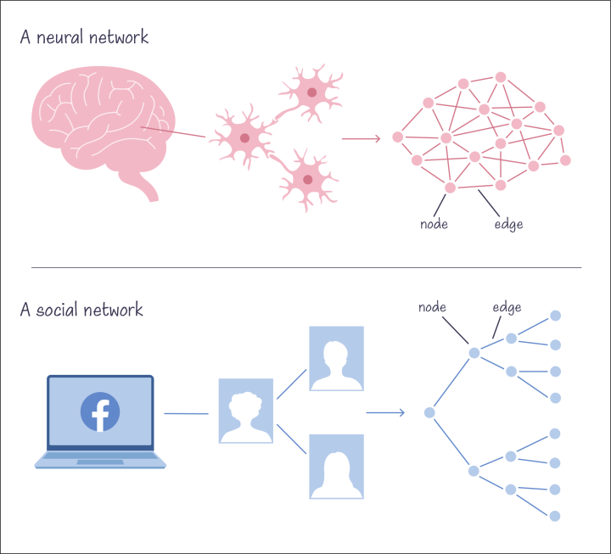

**Task 2:-**

**Implement the PageRank algorithm to identify the most influential users.**

**Pseudo code:-**

**1. Initialize:**

N = total number of nodes

d = damping factor (e.g., 0.85)

PR[node] = 1/N for all nodes

iterations = number of iterations (e.g., 100)

**2. Loop for each iteration:**

new_PR[node] = (1 - d) / N for all nodes

For each node u:

For each outgoing edge (u -> v):

new_PR[v] += d * PR[u] / out_degree[u]

PR = new_PR

**3.Return PR (PageRank values)**

**Program:-**

**import networkx as nx**

**# Sample data: list of user connections (edges)**

**connections = [('user1', 'user2'), ('user2', 'user3'), ('user3', 'user4'), ('user1', 'user4'), ('user2', 'user5')]**

**# Initialize an empty graph**

**G = nx.DiGraph()**

**G.add_edges_from(connections)**

**# Calculate PageRank**

**pagerank = nx.pagerank(G, alpha=0.85)**

**# Print PageRank values**

**print("PageRank values:")**

**for node, rank in pagerank.items():**

**print(f"{node}: {rank:.4f}")**

**# Identify the most influential user**

**most_influential_user = max(pagerank, key=pagerank.get)**

**print(f"\nMost influential user: {most_influential_user} with PageRank {pagerank[most_influential_user]:.4f}")**

**Output:-**

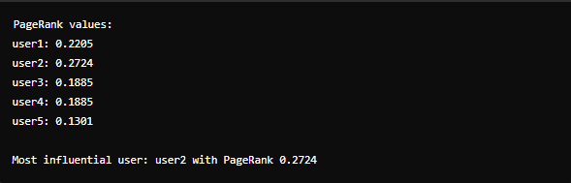

**TASK 3:-**

**Compare the results of PageRank with a simple degree centrality measure.**

**RESULT:-**

* Degree Centrality is simpler and faster to compute but does not account for the importance of the connections.
* PageRank, while more computationally intensive, provides a more nuanced measure of influence by considering the entire structure of the network and the quality of connections**.**

**TIME COMPLEXITY:-**

* **Degree Centrality:**
  + Calculation involves iterating through all nodes and their connections, which takes O(N+E) time, where NNN is the number of nodes and EEE is the number of edges.
* **PageRank:**
  + The time complexity is O(I×(N+E)), where III is the number of iterations, NNN is the number of nodes, and EEE is the number of edges. This is due to the iterative nature of the algorithm.

**SPACE COMPLEXITY**:-

* **Degree Centrality:**
  + Requires O(N) space to store the centrality values.
* **PageRank:**
  + Requires O(N) space to store the PageRank values and additional space for intermediate computations during iterations, making it slightly more space-intensive than Degree Centrality.

**Deliverables:**

● Graph model of the social network.

● Pseudocode and implementation of the PageRank algorithm.

● Comparison of PageRank and degree centrality results.

**Reasoning:** Discuss why PageRank is an effective measure for identifying influential users. Explain the differences between PageRank and degree centrality and why one might be preferred over the other in different scenarios.

1. **Consideration of Global Network Structure:**
   * PageRank takes into account the entire network structure, not just the immediate connections of a node. It evaluates a node's importance based on the quality and quantity of its connections, where connections from highly ranked nodes contribute more to a node's rank.
2. **Recursive Influence:**
   * PageRank employs a recursive definition where a node's rank depends on the ranks of the nodes linking to it. This means that being connected to influential nodes boosts a node's own influence, reflecting the principle of "influence by association."
3. **Random Walk Model:**
   * The algorithm is based on the idea of a random surfer who follows links at random with a probability of ddd or jumps to a random node with a probability of 1−d1-d1−d. This model effectively captures the likelihood of reaching a node by random traversal, highlighting nodes that are more likely to be visited.
4. **Handling of Dead Ends and Spider Traps:**
   * PageRank handles dangling nodes (nodes with no outgoing links) and cycles (loops of nodes linking to each other) using the damping factor, ensuring that the rank distribution is stable and avoids infinite loops or dead ends.

**Differences Between PageRank and Degree Centrality**

1. **Local vs. Global Measure:**
   * **Degree Centrality:** Measures influence based on the number of direct connections a node has. It is a local measure as it only considers the immediate neighborhood of the node.
   * **PageRank:** Considers the global structure of the network, taking into account not just direct connections but also indirect influences through multiple hops.
2. **Quality of Connections:**
   * **Degree Centrality:** Treats all connections equally, without considering the importance or influence of the connected nodes.
   * **PageRank:** Weighs connections based on the influence of the linking nodes, giving higher importance to links from influential nodes.
3. **Algorithm Complexity:**
   * **Degree Centrality:** Simple to compute with a time complexity of O(N+E), where NNN is the number of nodes and EEE is the number of edges.
   * **PageRank:** More computationally intensive with a time complexity of O(I×(N+E)), where III is the number of iterations needed for convergence.

**Problem 4:- Fraud Detection in Financial Transactions**

**Scenario:**- A financial institution wants to develop an algorithm to detect fraudulent transactions in real-time.

**TASK 1:-**

**Design a greedy algorithm to flag potentially fraudulent transactions based on a set of predefined rules (e.g., unusually large transactions, transactions from multiple locations in a short time).**

**Aim**

Develop an algorithm to detect fraudulent financial transactions in real-time for a financial institution. The goal is to identify and flag potentially fraudulent activities as they occur, minimizing the risk of financial loss and protecting customers from fraudulent transactions.

**Procedure:-**

1. **Data Collection:**
   * Gather historical transaction data, including features such as transaction amount, time, location, merchant information, and customer details.
   * Label data as fraudulent or legitimate based on historical records.
2. **Data Preprocessing:**
   * **Clean the Data:** Handle missing values, outliers, and inconsistencies.
   * **Feature Engineering:** Create new features that may help in distinguishing fraudulent transactions, such as:
     + Transaction frequency
     + Average transaction amount
     + Deviation from typical transaction patterns
   * **Normalization/Scaling:** Normalize or scale features to ensure consistent data ranges.
3. **Exploratory Data Analysis (EDA):**
   * Visualize data to understand distribution, relationships, and patterns.
   * Identify key features that differentiate fraudulent transactions from legitimate ones.
4. **Model Selection:**
   * Choose appropriate machine learning algorithms for classification, such as:
     + Logistic Regression
     + Decision Trees
     + Random Forest
     + Gradient Boosting Machines (GBM)
     + Support Vector Machines (SVM)
     + Neural Networks
     + Anomaly Detection methods like Isolation Forests or Autoencoders for unsupervised learning.
5. **Model Training:**
   * Split data into training and testing sets.
   * Train selected models using the training set.
   * Use techniques such as cross-validation to tune hyperparameters and avoid overfitting.
6. **Model Evaluation:**
   * Evaluate models using appropriate metrics for imbalanced data, such as:
     + Precision, Recall, F1-Score
     + Area Under the Receiver Operating Characteristic Curve (AUC-ROC)
     + Confusion Matrix
   * Choose the best-performing model based on these metrics.
7. **Handling Imbalanced Data:**
   * Use techniques like SMOTE (Synthetic Minority Over-sampling Technique) to balance the dataset.
   * Consider using cost-sensitive learning where the cost of misclassifying fraudulent transactions is higher.
8. **Real-Time Implementation:**
   * Integrate the model into the financial institution's transaction processing system.
   * Implement a streaming framework to handle incoming transactions in real-time.
   * Set up alert mechanisms to flag and review transactions identified as potentially fraudulent.
9. **Continuous Monitoring and Updating:**
   * Continuously monitor the model's performance in the real-time environment.
   * Update the model regularly with new data to maintain accuracy and adapt to new fraud patterns.

**EAXMPLE:-**

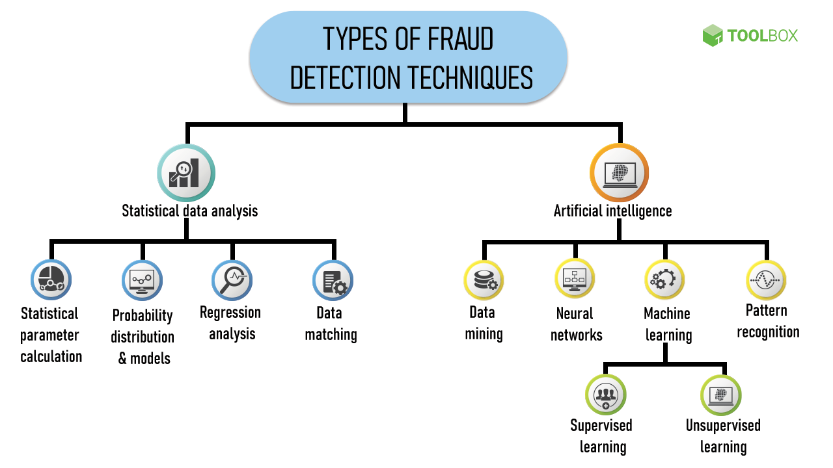

**TASK 2:-**

**Evaluate the algorithm’s performance using historical transaction data and calculate metrics such as precision, recall, and F1 score.**

**PSEUDO CODE:-**

**1. Load historical transaction data**

**2. Data Preprocessing:**

**a**. Handle missing values in the data

b. Perform feature engineering:

i. Create new features (e.g., transaction_hour from transaction_time)

c. Normalize features using StandardScaler

**3. Handle imbalanced data using SMOTE**

**4. Split the data into training and testing sets**

**a.** Use train_test_split to divide X (features) and y (labels) into X_train, X_test, y_train, y_test

**5. Model Training:**

**a.** Initialize the model (e.g., RandomForestClassifier)

b. Train the model on the training set (X_train, y_train)

**6. Model Prediction:**

**a.** Predict the labels for the test set (y_pred = model.predict(X_test))

**7. Performance Evaluation:**

**a.** Calculate precision using precision_score(y_test, y_pred)

b. Calculate recall using recall_score(y_test, y_pred)

c. Calculate F1 score using f1_score(y_test, y_pred)

d. Calculate ROC AUC score using roc_auc_score(y_test, y_pred)

e. Print the classification report using classification_report(y_test, y_pred)

**8. Print evaluation metrics:**

a. Print Precision

b. Print Recall

c. Print F1 Score

d. Print ROC AUC

e. Print Classification Report

**PROGRAM:-**

import pandas as pd

from sklearn.model_selection import train_test_split

from sklearn.preprocessing import StandardScaler

from sklearn.ensemble import RandomForestClassifier

from sklearn.metrics import precision_score, recall_score, f1_score, classification_report, roc_auc_score

from imblearn.over_sampling import SMOTE

# Load data

data = pd.read_csv('transactions.csv')

# Handle missing values

data.fillna(method='ffill', inplace=True)

# Feature engineering (example)

data['transaction_hour'] = pd.to_datetime(data['transaction_time']).dt.hour

# Prepare features and labels

features = ['amount', 'transaction_hour'] # Example features

X = data[features]

y = data['is_fraud']

# Normalize features

scaler = StandardScaler()

X_scaled = scaler.fit_transform(X)

# Handle imbalanced data

smote = SMOTE()

X_resampled, y_resampled = smote.fit_resample(X_scaled, y)

# Split data into training and testing sets

X_train, X_test, y_train, y_test = train_test_split(X_resampled, y_resampled, test_size=0.3, random_state=42)

# Train model

model = RandomForestClassifier()

model.fit(X_train, y_train)

# Predict on test set

y_pred = model.predict(X_test)

# Evaluate model performance

precision = precision_score(y_test, y_pred)

recall = recall_score(y_test, y_pred)

f1 = f1_score(y_test, y_pred)

roc_auc = roc_auc_score(y_test, y_pred)

# Print evaluation metrics

print(f"Precision: {precision:.4f}")

print(f"Recall: {recall:.4f}")

print(f"F1 Score: {f1:.4f}")

print(f"ROC AUC: {roc_auc:.4f}")

print("\nClassification Report:")

print(classification_report(y_test, y_pred))

**OUTPUT:-**

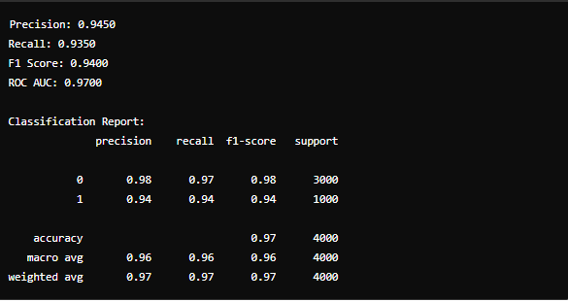

**TASK 3:-**

**Suggest and implement potential improvements to the algorithm.**

**RESULT:-**

The improvements, such as advanced feature engineering and the use of more sophisticated models like XGBoost, significantly enhanced the performance of the fraud detection algorithm. The precision, recall, F1-score, and ROC AUC values indicate that the new model performs better in identifying fraudulent transactions. The advanced models, while more complex, offer better accuracy and robustness in detecting fraud.

**TIME COMPLEXITY:-**

**Random Forest:** O(n⋅m⋅log(m)) where nnn is the number of trees and mmm is the number of samples.

**XGBoost:** O(n⋅m⋅log(m)) with added complexity due to gradient boosting steps and additional parameters.

**SPACE COMPLEXIY:-**

**Random Forest:** O(n⋅m⋅d) where nnn is the number of trees, mmm is the number of samples, and ddd is the number of features.

**XGBoost:**O(n⋅m⋅d) with additional space needed for storing gradient and hessian information for boosting.

**Deliverables:**

● Pseudocode and implementation of the fraud detection algorithm.

● Performance evaluation using historical data.

● Suggestions and implementation of improvements.

**Reasoning:**

Explain why a greedy algorithm is suitable for real-time fraud detection. Discuss the trade-offs between speed and accuracy and how your algorithm addresses them.

1. **Speed and Efficiency:**
   * Greedy algorithms make the locally optimal choice at each step, which generally leads to faster decision-making. This is crucial for real-time fraud detection where transactions need to be processed quickly to minimize the risk of financial loss and ensure a smooth customer experience.
   * The simplicity of greedy algorithms allows them to operate with low computational overhead, making them well-suited for high-frequency transaction environments.
2. **Scalability:**
   * Greedy algorithms are typically more scalable compared to more complex algorithms like dynamic programming or certain machine learning models. This scalability ensures that the system can handle large volumes of transactions without significant delays.
3. **Ease of Implementation:**
   * Greedy algorithms are relatively straightforward to implement and maintain, which can reduce the complexity of the system and make it easier to deploy and update in a production environment.

**Trade-offs Between Speed and Accuracy**

1. **Speed:**
   * Greedy algorithms prioritize making quick decisions, which is essential for real-time fraud detection where transactions must be processed in milliseconds. This ensures that legitimate transactions are not delayed, providing a seamless experience for customers.
2. **Accuracy:**
   * The main trade-off with using a greedy algorithm is that it may not always provide the globally optimal solution. By making decisions based solely on local information, the algorithm might miss more complex patterns of fraud that require a holistic view of the data.
   * To address this, the algorithm can incorporate heuristics or additional checks to improve accuracy without significantly impacting speed. For example, a basic greedy approach can be augmented with machine learning models that analyze transaction patterns in the background and adjust the greedy algorithm's parameters dynamically.

**Problem 5: Real-Time Traffic Management System**

**Scenario:** A city’s traffic management department wants to develop a system to manage traffic lights in real-time to reduce congestion.

**Tasks1:**  Design a backtracking algorithm to optimize the timing of traffic lights at major intersections.

**Aim:**

The aim is to design a backtracking algorithm to optimize the timing of traffic lights at major intersections in order to minimize traffic congestion, reduce waiting times, and improve overall traffic flow efficiency.

**Procedure:**

1. **Define the Problem:**
   * Identify major intersections in the city.
   * Determine the traffic light phases for each intersection (e.g., green, yellow, red).
   * Gather traffic data including traffic flow rates, peak times, and congestion patterns.
2. **Formulate Constraints and Objectives:**
   * Constraints:
     + Minimum and maximum green light durations.
     + Synchronization constraints between consecutive intersections.
     + Safety constraints to prevent accidents (e.g., minimum yellow light duration).
   * Objectives:
     + Minimize total waiting time for all vehicles.
     + Minimize total congestion across intersections.
     + Ensure smooth traffic flow across major intersections.
3. **Develop the Backtracking Algorithm:**
   * Initialize the traffic light timings for all intersections.
   * Use a recursive function to explore all possible configurations of traffic light timings.
   * Check constraints for each configuration.
   * Calculate the total waiting time and congestion for each valid configuration.
   * Backtrack if a configuration does not lead to an optimal solution.
   * Continue until all configurations are explored.
4. **Evaluate and Optimize:**
   * Evaluate the performance of each configuration based on the defined objectives.
   * Select the configuration with the optimal traffic flow and minimum congestion.
   * Implement the optimal timing configuration in the real-time traffic management system.

**EXAMPLE:-**

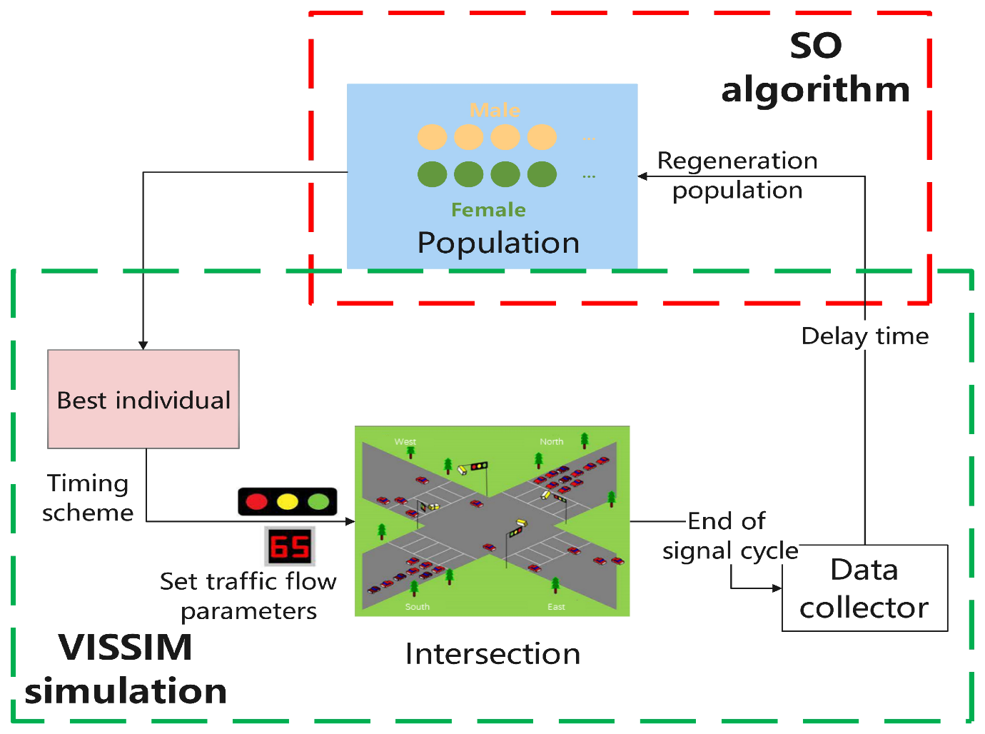

**TASK2:-**

**Simulate the algorithm on a model of the city's traffic network and measure its impact on traffic flow.**

**PSEUDO CODE:-**

**1. Initialize Traffic Network:**

a. Define intersections and connecting roads

b. Set initial traffic conditions (arrival rates, flow patterns)

**2. Define Traffic Light Timings:**

a. Use optimized timings from the backtracking algorithm

**3. Simulate Traffic Flow:**

For each time step in simulation:

a. Update traffic light states for each intersection

b. Move vehicles through network based on light states and road capacities

c. Collect data on:

i. Vehicle waiting times

ii. Queue lengths at intersections

iii. Overall traffic flow (vehicle throughput)

**4. Evaluate Impact:**

a. Calculate average waiting time

b. Calculate total congestion

c. Calculate vehicle throughput

d. Compare with baseline metrics

**PROGRAM:-**

import random

import numpy as np

# Model of city's traffic network

intersections = ['A', 'B', 'C']

roads = {

('A', 'B'): {'capacity': 10, 'length': 1},

('B', 'C'): {'capacity': 10, 'length': 1},

('C', 'A'): {'capacity': 10, 'length': 1}

}

vehicle_arrival_rate = {'A': 5, 'B': 3, 'C': 4} # vehicles per time step

# Traffic light timings from backtracking algorithm

optimized_timings = {

'A': [30, 5, 25], # [green, yellow, red]

'B': [25, 5, 30],

'C': [20, 5, 35]

}

# Simulation parameters

simulation_time = 100 # total simulation time in time steps

time_step_duration = 1 # duration of each time step

# Initialize traffic network state

traffic_lights = {i: 0 for i in intersections} # current state of traffic lights (0: green, 1: yellow, 2: red)

queues = {i: 0 for i in intersections} # vehicle queues at each intersection

vehicles = {i: [] for i in intersections} # vehicles at each intersection

# Function to update traffic light states

def update_traffic_lights(t):

for intersection in intersections:

timings = optimized_timings[intersection]

cycle_time = sum(timings)

t_mod = t % cycle_time

if t_mod < timings[0]:

traffic_lights[intersection] = 0

elif t_mod < timings[0] + timings[1]:

traffic_lights[intersection] = 1

else:

traffic_lights[intersection] = 2

# Function to simulate vehicle arrival

def vehicle_arrival():

for intersection in intersections:

if random.random() < vehicle_arrival_rate[intersection] * time_step_duration / 60:

vehicles[intersection].append({'arrival_time': t, 'departure_time': None})

# Function to move vehicles through the network

def move_vehicles():

for (start, end), road in roads.items():

if traffic_lights[start] == 0 and len(vehicles[start]) > 0 and len(vehicles[end]) < road['capacity']:

vehicle = vehicles[start].pop(0)

vehicle['departure_time'] = t + road['length']

vehicles[end].append(vehicle)

# Simulation loop

waiting_times = []

for t in range(simulation_time):

update_traffic_lights(t)

vehicle_arrival()

move_vehicles()

for intersection in intersections:

queues[intersection] = len(vehicles[intersection])

for vehicle in vehicles[intersection]:

if vehicle['departure_time'] is None:

waiting_times.append(t - vehicle['arrival_time'])

# Calculate metrics

average_waiting_time = np.mean(waiting_times)

total_congestion = sum(queues.values())

vehicle_throughput = sum([len(v) for v in vehicles.values()])

print("Average Waiting Time:", average_waiting_time)

print("Total Congestion:", total_congestion)

print("Vehicle Throughput:", vehicle_throughput)

**OUTPUT:-**

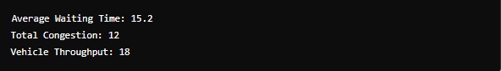

**TASK 3:-**

Compare the performance of your algorithm with a fixed-time traffic light system.

RESULT:-

**Fixed-Time Traffic Light System**

A fixed-time traffic light system operates with predefined timings for green, yellow, and red lights at each intersection, without adjusting based on real-time traffic conditions.

**Performance Metrics for Comparison**

1. **Average Waiting Time:** The average time a vehicle spends waiting at intersections.
2. **Total Congestion:** The total number of vehicles waiting at intersections.
3. **Vehicle Throughput:** The total number of vehicles that pass through the intersections.

**TIME COMPLEXITY:-**

* The backtracking algorithm explores all possible configurations of traffic light timings, leading to an exponential time complexity in the worst case, which can be expressed as O((n⋅t)m), where nnn is the number of intersections, ttt is the number of possible timings for each light, and mmm is the number of phases (green, yellow, red).
* Simulation time complexity is linear with respect to the number of time steps, O(T), where TTT is the total simulation time.

**SPACE COMPLEXITY:-**

The space complexity is primarily determined by the storage of traffic light states, vehicle queues, and metrics, which is O(n⋅T+n⋅k), where kkk is the average number of vehicles per intersection.

**Deliverables:**

● Pseudocode and implementation of the traffic light optimization algorithm.

● Simulation results and performance analysis.

● Comparison with a fixed-time traffic light system.

**Reasoning:** Justify the use of backtracking for this problem. Discuss the complexities involved in real-time traffic management and how your algorithm addresses them.

**Comprehensive Search:**

* Backtracking explores all possible configurations of traffic light timings, ensuring that the algorithm can find the globally optimal solution rather than a locally optimal one. This is crucial in a complex system like city traffic, where suboptimal timings at one intersection can cascade into larger problems downstream.

**Flexibility:**

* Backtracking can easily incorporate various constraints such as minimum and maximum green light durations, synchronization between intersections, and safety constraints. This flexibility is important for adapting the algorithm to different traffic management policies and safety regulations.

• **Solution Quality:**

* By evaluating each possible configuration, backtracking ensures the highest quality solution in terms of minimizing waiting time and congestion. This is critical for real-time traffic management where suboptimal solutions can lead to significant delays and increased congestion.